- Follow the points that are given from the Dr. attached
- Focus on the qualitative methods
- Delete all the quantitively methods
- Change the topic as it agreed from the teacher . you will see the comments from the teacher down
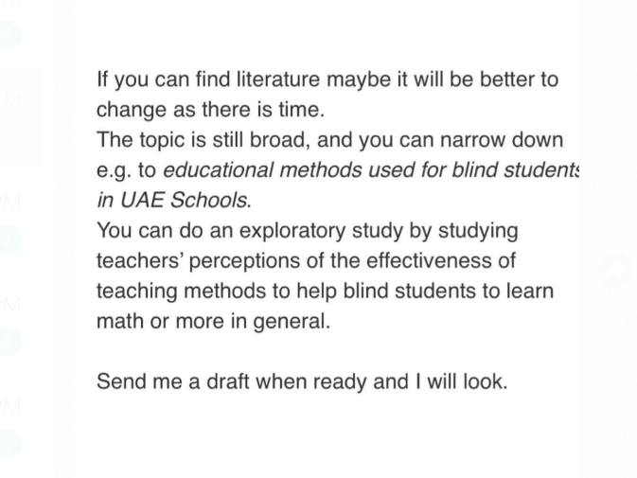

- Add the missing
- 2. Literature review ( focus on the studies in blind)
- 3. Research aim
- 4. Research question or line of inquiry
- 5. Epistemology
- 6. Theoretical perspective
10. Ethical issues
- 11. Conclusion

